Bahria University,

Karachi Campus



COURSE: CSC-113 COMPUTER PROGRAMMING

TERM: FALL 2019, CLASS: BSE- 1 (B)

Submitted By:

M MUAZ SHAHZAD 02-131202-081

(Name) (Reg. No.)

Submitted To:

Engr. Adnan ur rehman/ Engr. Ramsha Mashood

Signed Remarks: Score:

INDEX

|  |  |  |  |  |
| --- | --- | --- | --- | --- |
| SNO | DATE | LAB NO | LAB OBJECTIVE | SIGN |
| 01 | 22-Dec-2020 | 11 | METHODS |  |
|  |  |  |  |  |
|  |  |  |  |  |
|  |  |  |  |  |
|  |  |  |  |  |
|  |  |  |  |  |
|  |  |  |  |  |
|  |  |  |  |  |
|  |  |  |  |  |
|  |  |  |  |  |
|  |  |  |  |  |
|  |  |  |  |  |
|  |  |  |  |  |
|  |  |  |  |  |
| SNO | DATE | LAB NO | LAB OBJECTIVE | SIGN |
|  |  |  |  |  |
|  |  |  |  |  |
|  |  |  |  |  |
|  |  |  |  |  |
|  |  |  |  |  |
|  |  |  |  |  |
|  |  |  |  |  |
|  |  |  |  |  |
|  |  |  |  |  |
|  |  |  |  |  |
|  |  |  |  |  |
|  |  |  |  |  |
|  |  |  |  |  |
|  |  |  |  |  |
|  |  |  |  |  |

Bahria University,

Karachi Campus



LAB EXPERIMENT NO.

11

LIST OF TASKS

|  |  |
| --- | --- |
| TASK NO | OBJECTIVE |
| **01** | **Write a method named square cube () that computes the square and cube of the value passed to it and display the result. Ask the user to provide the integer input in the main () and then call the function.** |
| **02** | **Write a method table () which generates multiplicative table of an integer. The function receives three integers as its arguments. The first argument determines the table to be generated while the second and the third integer tell the starting and ending point respectively. Ask the user to provide the three integer as input in the main ().** |
| **03** | **Create two function to find min and maximum value of any int array.** |
| **04** | **Take input of an array in on method and print reverse of that array.** |
| **05** | **Design a fully functional calculator using function.** |
| 06 | Design a WFP of your marks sheet. |

Submitted On:

29/12/2020

(Date: DD/MM/YY)

**Task No. 1: Write a method named square cube () that computes the square and cube of the value passed to it and display the result. Ask the user to provide the integer input in the main () and then call the function.**

**Solution:**static void Header()

{

Console.WriteLine("\t\t|===============|");

Console.WriteLine("\t\t|M MUAZ SHAHZAD |");

Console.WriteLine("\t\t|02-131202-081 |");

Console.WriteLine("\t\t|Task 1 |");

Console.WriteLine("\t\t|===============|");

}

static void Square_Cube(int a)

{

double sqr = Math.Pow(a, 2);

double sqrt = Math.Pow(a, 3);

Console.WriteLine("==============================================");

Console.WriteLine("\t\tSquare Of Given Num Is : "+ sqr);

Console.WriteLine("==============================================");

Console.WriteLine("\t\tCube Of Given Num Is : "+ sqrt);

Console.WriteLine("==============================================");

}

static void Main(string[] args)

{

Header();

Console.WriteLine("\n==============================================");

Console.Write("\t\tEnter A Number : ");

int a = Convert.ToInt32(Console.ReadLine());

Square_Cube(a);

Console.ReadLine();

**Output: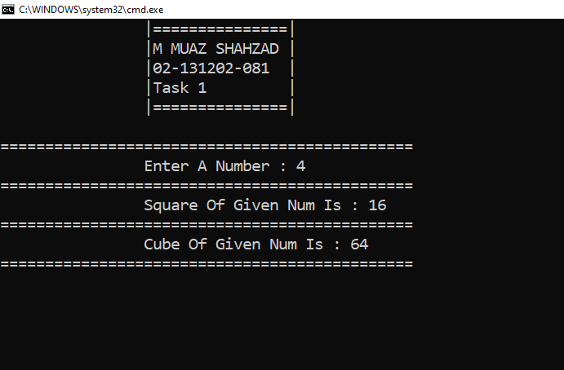 Task No. 2: Write a method table () which generates multiplicative table of an integer. The function receives three integers as its arguments. The first argument determines the table to be generated while the second and the third integer tell the starting and ending point respectively. Ask the user to provide the three integer as input in the main ().**

**Solution:**

static void table(int k,int start, int end )

{

for(int j = start; j <= end;j++)

{

int result = k * j;

Console.WriteLine("\n\t\t{0} X {1} = {2} ", k, j, k * j);

}

Console.ReadLine();

}

static void Main(string[] args)

{

Console.WriteLine("\t\t|===============|");

Console.WriteLine("\t\t|M MUAZ SHAHZAD |");

Console.WriteLine("\t\t|02-131202-081 |");

Console.WriteLine("\t\t|Task 2 |");

Console.WriteLine("\t\t|===============|");

Console.WriteLine("\n=============================================================");

Console.Write("\tEnter A Num For Printing Table : ");

int k = Convert.ToInt32(Console.ReadLine());

Console.Write("\n\tStarting Point Of The Table : ");

int start = Convert.ToInt32(Console.ReadLine());

Console.Write("\n\tEnding Point Of The Table : ");

int end = Convert.ToInt32(Console.ReadLine());

table(k, start, end);

Console.Read();

**Output:**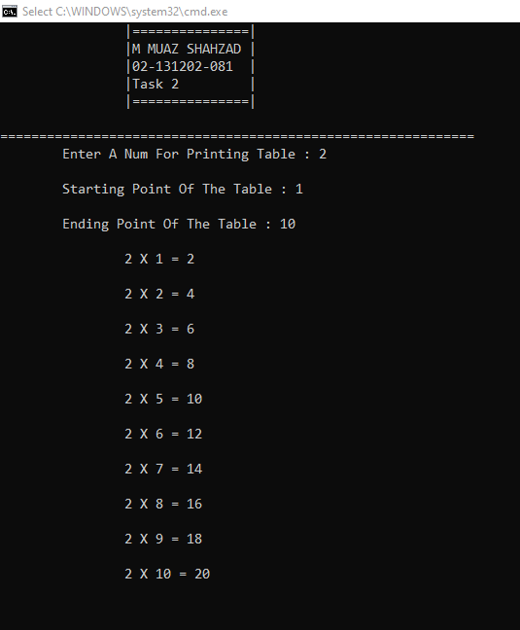

**Task No. 3: Create two function to find min and maximum value of any int array.**

**Solution:**static void Minvalue(int[] array) //Min() Function

{

Console.WriteLine("\n\t\t===================================");

Console.WriteLine("\t\tMinimum Value in the array is : {0} ", array.Min());

}

static void Maxvalue(int[] array) //Max() Function

{

Console.WriteLine("\t\tMaximum Value in the array is : {0} ", array.Max());

Console.WriteLine("\t\t===================================");

Console.ReadLine();

}

static void Main(string[] args)

{

Console.WriteLine("\t\t|===============|");

Console.WriteLine("\t\t|M MUAZ SHAHZAD |");

Console.WriteLine("\t\t|02-131202-081 |");

Console.WriteLine("\t\t|Task 3 |");

Console.WriteLine("\t\t|===============|");

Console.WriteLine("\n\t\t===============================");

Console.WriteLine("\t\tEnter 5 Elements of an Array ");

Console.WriteLine("\t\t===============================");

int[] array = new int[5];

for (int k = 0; k < 5; k++)

{

Console.Write("\n\t\tElement at {0} index: ", k);

array[k] = Convert.ToInt32(Console.ReadLine());

}

for (int k = 0; k < 5; k++)

{

Console.WriteLine("\n\t\tElement : {0} ", array[k]);

}

Minvalue(array);

Maxvalue(array);

**Output:**

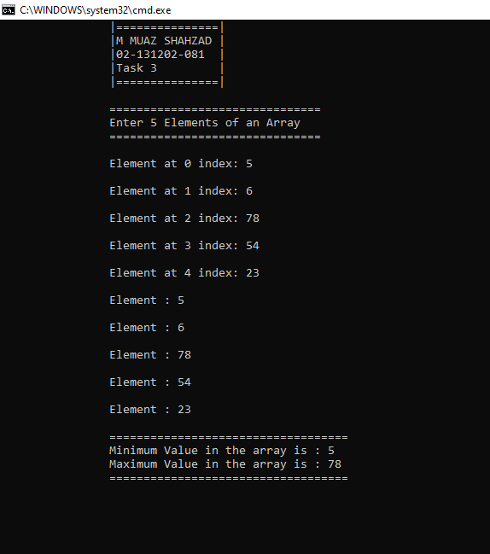  
  
 **Task No. 4: Take input of an array in on method and print reverse of that array.**

**Solution:**static void Header()

{

Console.WriteLine("\t\t|===============|");

Console.WriteLine("\t\t|M MUAZ SHAHZAD |");

Console.WriteLine("\t\t|02-131202-081 |");

Console.WriteLine("\t\t|Task 4 |");

Console.WriteLine("\t\t|===============|");

}

static void Arrays(int[] a )

{

int x = int.Parse(Console.ReadLine());

for (int r = 0; r < x; r++)

{

Console.Write("\nElement Of {0} Index : ", r);

a[r] = int.Parse(Console.ReadLine());

}

for(int r = 0; r < x; r++)

{

Console.WriteLine("\t============");

Console.WriteLine("\tElement : "+ a[r]);

}

Console.WriteLine("\t============");

Console.WriteLine("\nReverse Order Of The Array : ");

for(int r = x-1; r >= 0; r--)

{

Console.WriteLine("\t============");

Console.WriteLine("\tElement : " + a[r]);

}

Console.WriteLine("\t============");

Console.ReadLine();

}

static void Main(string[] args)

{

Header();

int[] z = new int[20];

Console.WriteLine("\n=================================");

Console.Write("Enter A Num For Printing Arrays : ");

Arrays(z);

**Output:**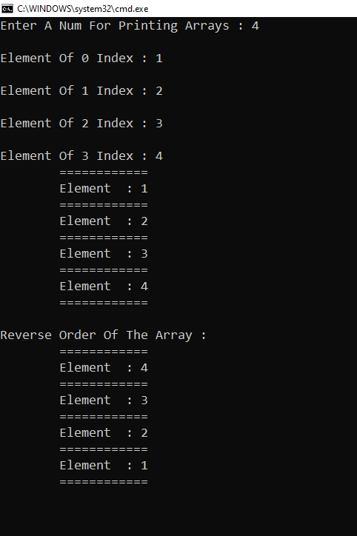

**Task No. 5: Design a fully functional calculator using function.**

**Solution:**static int Process(int info, int a, int b)

{

int result = 0;

switch (info)

{

case 1:

{

result = a + b;

Console.WriteLine("\n\t\t====================");

Console.WriteLine("\t\tAddition {0} + {1} = {2} ",a,b,result);

Console.WriteLine("\t\t====================");

Console.ReadLine();

break;

}

case 2:

{

result = a - b;

Console.WriteLine("\n\t\t=======================");

Console.WriteLine("\t\tSubstraction {0} - {1} = {2} ", a, b, result);

Console.WriteLine("\t\t=======================");

Console.ReadLine();

break;

}

case 3:

{

result = a * b;

Console.WriteLine("\n\t\t============================");

Console.WriteLine("\t\tMultiplication {0} * {1} = {2} ", a, b, result);

Console.WriteLine("\t\t============================");

Console.ReadLine();

break;

}

case 4:

{

result = a / b;

Console.WriteLine("\n\t\t====================");

Console.WriteLine("\t\tDivision {0} / {1} = {2} ", a, b, result);

Console.WriteLine("\t\t====================");

Console.ReadLine();

break;

}

}

return result;

}

static void Main(string[] args)

{

Console.WriteLine("\t\t|===============|");

Console.WriteLine("\t\t|M MUAZ SHAHZAD |");

Console.WriteLine("\t\t|02-131202-081 |");

Console.WriteLine("\t\t|Task 4 |");

Console.WriteLine("\t\t|===============|");

Console.WriteLine("\n=============================================");

Console.WriteLine("\t\tPress 1 For Addition ");

Console.WriteLine("\t\tPress 2 For Substraction ");

Console.WriteLine("\t\tPress 3 For Multiplicaton ");

Console.WriteLine("\t\tPress 4 For Division ");

Console.Write("\n\t\tSelect B/w 1 to 4 : ");

int info = Convert.ToInt32(Console.ReadLine());

Console.Write("\t\tEnter First Num : ");

int a = Convert.ToInt32(Console.ReadLine());

Console.Write("\t\tEnter Second Num : ");

int b = Convert.ToInt32(Console.ReadLine());

Process(info, a, b);

**Output:**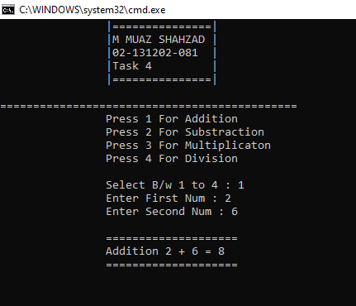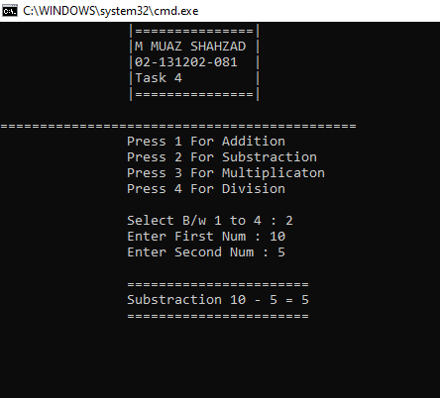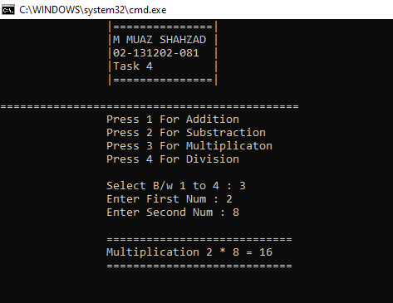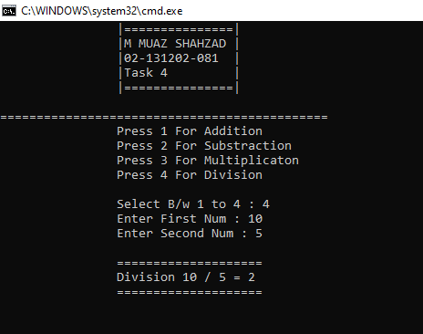

**Task No. 6: Design a WFP of your marks sheet.**

**Solution:**static void Methodmarksheet()

{

Console.WriteLine(" | BOARD OF INTERMEDIATE EDUCATION KARACHI |");

Console.WriteLine(" |-----------------------------------------------------------|");

Console.WriteLine(" | H.S.C PART-1 INTERMEDIATE EXAMINATION (ANNAUL - 2019) |");

Console.WriteLine(" |-----------------------------------------------------------|");

Console.WriteLine(" | STATEMENT OF MARKS |");

Console.WriteLine(" |-----------------------------------------------------------|");

Console.WriteLine("--------------------------------------------------------------------");

Console.WriteLine(" Marks Sheet No. 00140708-2");

Console.WriteLine(" Group PRE-ENGINEERING");

Console.WriteLine(" Roll No 134222");

Console.WriteLine(" Enrollment NO APCS/SE/E-0027/2019");

Console.WriteLine(" Name MUHAMMAD MUAZ SHAHZAD");

Console.WriteLine(" Father Name MUHAMMAD SHAHZAD");

Console.WriteLine(" College Army Public College");

Console.WriteLine("--------------------------------------------------------------------------------------------------");

Console.WriteLine("| | Part 1 Marks | | |");

Console.WriteLine("| |-----------------------------------------------| | |");

Console.WriteLine("| Subjects | MAX | SECURED | % | REMARKS |");

Console.WriteLine("| |---------------------|-------------------------| | |");

Console.WriteLine("| | TH | PR | TH | PR | | |");

Console.WriteLine("|--------------------|----------|----------|-----------|-------------|--------------|-------------|");

Console.WriteLine("| URDU NORMAL | 100 | - | 60 | - | 60 | PASS |");

Console.WriteLine("|--------------------|----------|----------|-----------|-------------|--------------|-------------|");

Console.WriteLine("| ENGLISH NORMAL | 100 | - | 60 | - | 60 | PASS |");

Console.WriteLine("|--------------------|----------|----------|-----------|-------------|--------------|-------------|");

Console.WriteLine("| ISLAMIC EDUCATION | 50 | - | 48 | - | 96 | PASS |");

Console.WriteLine("|--------------------|----------|----------|-----------|-------------|--------------|-------------|");

Console.WriteLine("| CHEMISTRY | 85 | 15 | 68 | 13 | 81 | PASS |");

Console.WriteLine("|--------------------|----------|----------|-----------|-------------|--------------|-------------|");

Console.WriteLine("| PHYSICS | 85 | 15 | 65 | 14 | 79 | PASS |");

Console.WriteLine("|--------------------|----------|----------|-----------|-------------|--------------|-------------|");

Console.WriteLine("| MATHEMATICS | 100 | - | 74 | - | 74 | PASS |");

Console.WriteLine("|--------------------|----------|----------|-----------|-------------|--------------|-------------|");

Console.WriteLine("| | MAX MARKS | SECURE MARKS IN | PASSED PAPER | GRADES |");

Console.WriteLine("| TOTAL | | PASSED PAPERS | % | |");

Console.WriteLine("| |---------------------|-------------------------|--------------|-------------|");

Console.WriteLine("| | 550 | 402 | 73.09 | PASS |");

Console.WriteLine("|--------------------|---------------------|-------------------------|--------------|-------------|");

Console.WriteLine("| IN WORDS | FOUR HUNDRED TWO ONLY |");

Console.WriteLine("---------------------------------------------------------------------------------------------------");

}

static void Main(string[] args)

{

Console.Write("Press Enter For Marksheet: ");

Console.ReadLine();

Methodmarksheet();

Console.ReadLine();

**Output:**